

SCHOOL OF COMPUTER SCIENCE & ENGINEERING
SUBJECT: DATABASE MANAGEMENT SYSTEM
SUBJECT CODE: 25ECSC208

Course Activity: DATABASE DESIGN (10 Marks)
- ER Diagram Design: Model entities and their relationships.
- Relational Mapping: The ER diagram is mapped to a relational schema using a step-by-step approach to ensure an efficient structure.
- Normalization: Finally, the schema is normalized up to BCNF to minimize redundancy and ensure data integrity.
Team 10 : ONLINE CAR RENTAL SYSTEM

An Online Car Rental System helps by automating and simplifying the entire car hiring process for both customers and the rental company.
- Easy Access to Cars
- Quick Booking
Section: E Submission Date: 07/01/2026

SUBMITTED BY
Team | Rl. No. | SRN | Name | Remarks
10 | 522 | 01fe24BCS108 | Srusti S Koliwad
10 | 530 | 01FE24BCS242 | Sahana C Gunjetti
10 | 558 | 01FE24BCS601 | Kanchana
10 | 560 | 01FE24BCS736 | Shrusti Hiremath

Academic: 2025-26

ONLINE CAR RENTAL SYSTEM

PROBLEM STATEMENT :-

The Online Car Rental System is designed to automate and manage the process of renting cars through an online platform. Traditional car rental services involve manual booking, paperwork, and limited availability tracking, which can lead to errors, delays, and poor customer experience.

There is a need for an Online Car Rental System that provides a centralized digital platform where customers can search and reserve cars anytime, and the company can efficiently manage vehicles, bookings, and payments. The proposed system aims to automate the rental workflow, ensure accuracy, improve security, and deliver fast, transparent, and reliable car hiring services.

OBJECTIVES:-

- To provide online search and booking of rental cars anytime.

- To automate car availability and reservation management.

- To enable secure digital payment and instant billing.

- To maintain centralized database for customers and vehicles.

- To generate reports for effective rental business control.

SYSTEM DESIGN

ENTITIES AND ATTRIBUTES :-

- Customer

- Customer ID (PK)
- Name
- Email
- Phone
- Address
- Driving License No

- Car

- Car ID (PK)
- Model
- Brand
- Car Type (SUV, Sedan, etc.)
- Registration No
- Rental Rate Per Day
- Status (Available / Rented)
- Fuel type
- Seating capacity

- Booking

- Booking ID (PK)
- Booking Date
- StartDate
- End Date
- Total Amount
- Pickup location
- Drop location

- Payment

- Payment ID (PK)
- Payment Date
- Amount
- Payment Mode (UPI, Card, Cash)
- Payment Status
- Admin
- Admin ID (PK)
- Name
- Phone no.
REPRESENTATION OF ENTITIES AND ATTRIBUTES
CUSTOMER
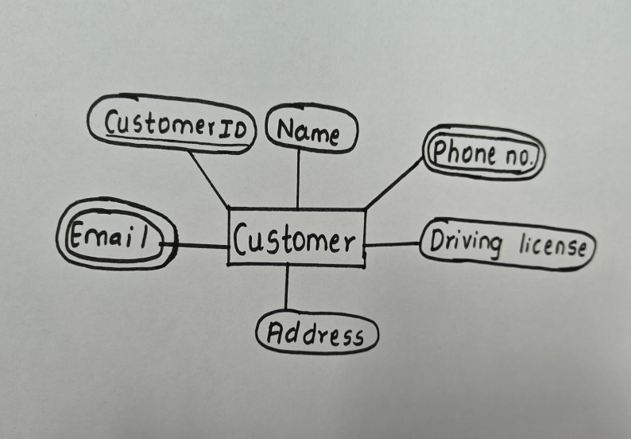

BOOKING
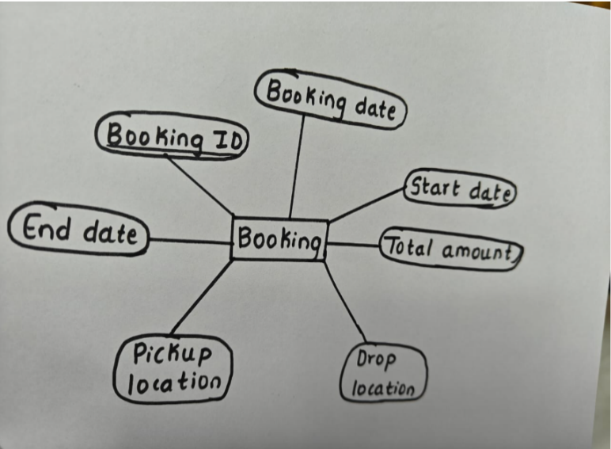

CAR
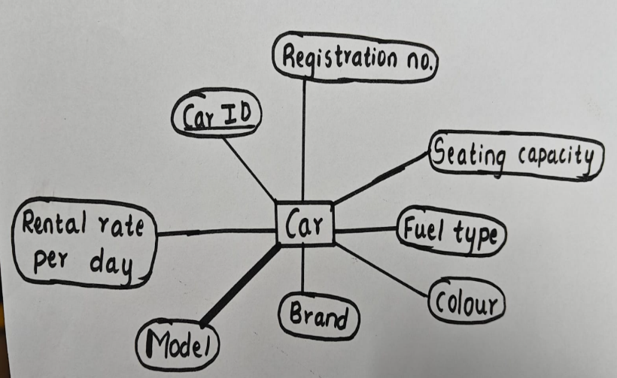

ADMIN
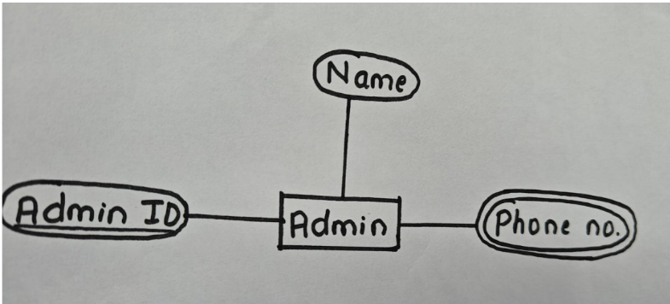

Relationships with Cardinality

- Customer – Booking
- One customer can make many bookings
- Relationship: Makes
- Cardinality: 1 : M

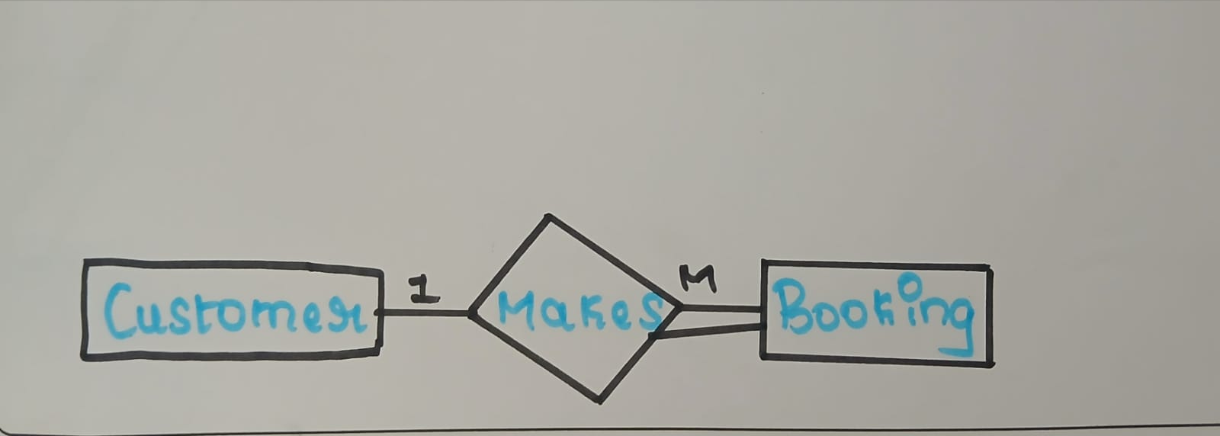

- Booking – Car
- One booking assigns one car
- One car can be booked many times
- Relationship: Assigned To
- Cardinality: 1 : M

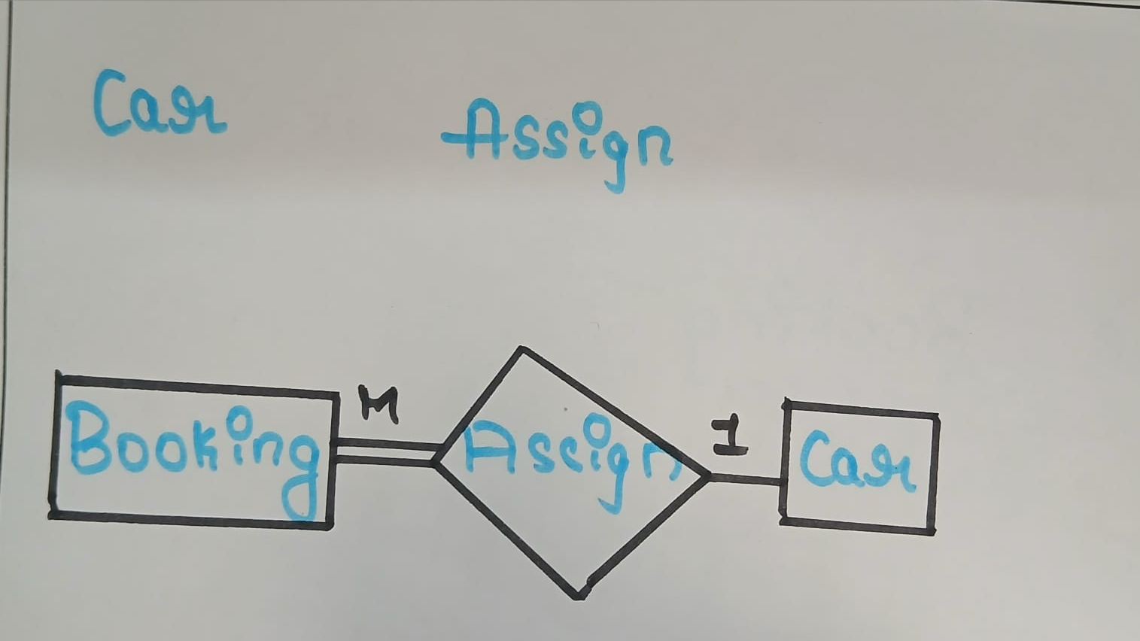

- Booking – Payment
- One booking generates one payment
- One payment is for one booking
- Cardinality: 1 : 1

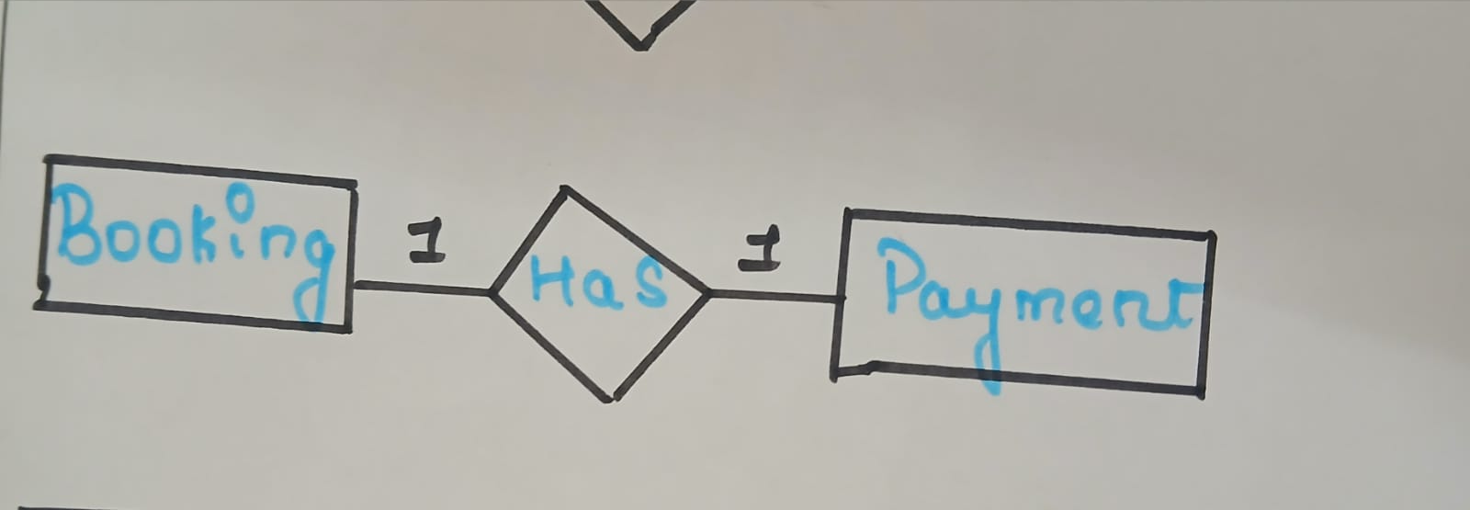

- Admin – Car
- Admin manages multiple cars
- Admin manages multiple cars
- Relationship: Manages
- Cardinality: 1 : M

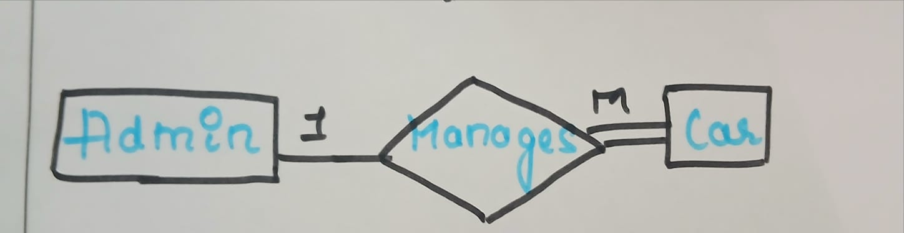

- Admin – Payment

- One admin can handle many payments

- Each payment is handled by one admin

- Relationship: Handles

- Cardinality: 1 : M

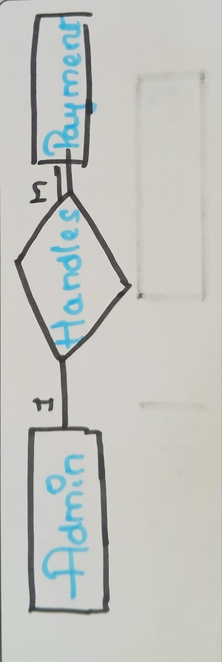

Relationship | Entities | Cardinality
Makes | CUSTOMER – BOOKING | 1 : M
Assigned To | CAR – BOOKING | 1 : M
Has | BOOKING – PAYMENT | 1 : 1
Manages | ADMIN – CAR | 1 : M
Handles | ADMIN – PAYMENT | 1 : M

ER DIAGRAM:

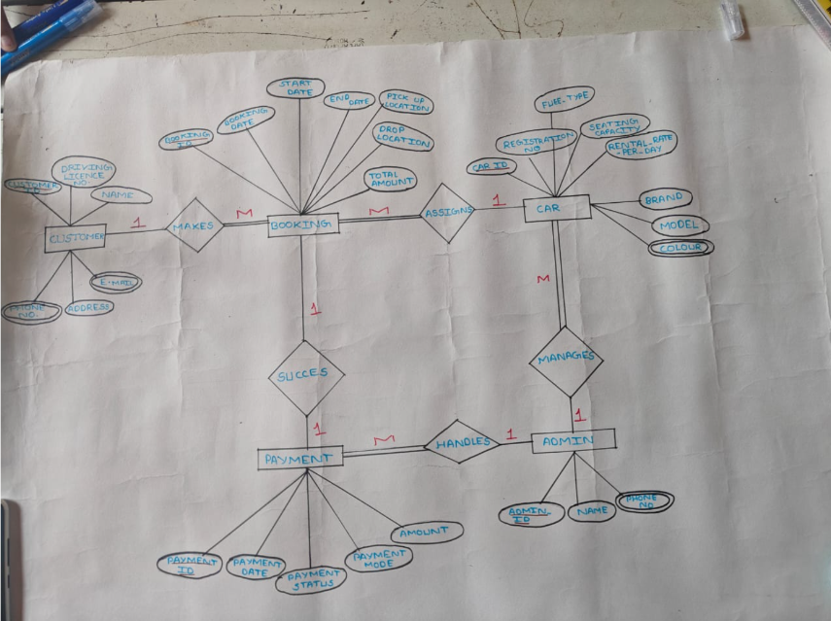

RELATIONAL SCHEMA
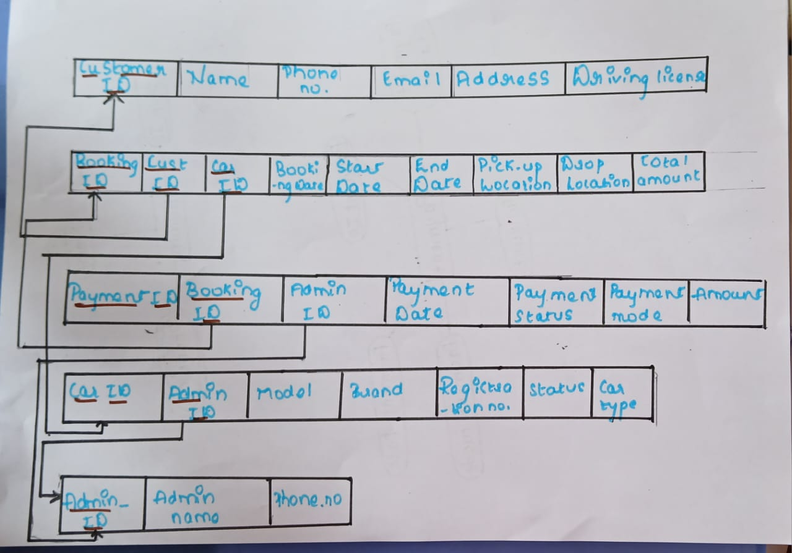
CUSTOMER

CUSTOMER(
cust_id PK,
name,
driving_license,
phone_number,
email,
address
)
CAR

CAR(
car_id PK,
fuel_type,
seating_capacity,
rental_rate_per_day,
registration_number,
brand,
model,
status,
admin_id FK → ADMIN(admin_id)
)
BOOKING

BOOKING(
booking_id PK,
booking_date,
start_date,
end_date,
pickup_location,
drop_location,
total_amount,
cust_id FK → CUSTOMER(cust_id),
car_id FK → CAR(car_id)
)
PAYMENT

PAYMENT(
payment_id PK,
payment_date,
payment_status,
payment_mode,
amount,
booking_id FK → BOOKING(booking_id),
admin_id FK → ADMIN(admin_id)
)

ADMIN
ADMIN(
admin_id PK,
name,
phone_no
)

Draw a Data Dictionary illustrating the information you have identified

Object (Entity) | Name (Attribute) | Type (Data Type) | Description | Primary Key | Foreign Key
CUSTOMER | customer_id | Integer | Unique identification number for customer | Yes | No
 | name | Varchar | Name of the customer | No | No
 | phone_number | Varchar | Contact number of customer | No | No
 | email | Varchar | Email address of customer | No | No
 | address | Varchar | Residential address of customer | No | No
 | driving_license | Varchar | Driving license number | No | No
ADMIN | admin_id | Integer | Unique identification number for admin | Yes | No
 | name | Varchar | Name of admin | No | No
 | phone_number | Varchar | Contact number of admin | No | No
CAR | car_id | Integer | Unique identification number for car | Yes | No
 | registration_number | Varchar | Vehicle registration number | No | No
 | fuel_type | Varchar | Fuel type of car | No | No
 | seating_capacity | Integer | Seating capacity of car | No | No
 | rental_rate_per_day | Number | Rental charge per day | No | No
 | brand | Varchar | Brand of the car | No | No
 | model | Varchar | Model of the car | No | No
 | status | Varchar | Availability status of car | No | No
 | admin_id | Integer | Admin managing the car | No | Yes
BOOKING | booking_id | Integer | Unique booking identification number | Yes | No
 | booking_date | Date | Date when booking was made | No | No
 | start_date | Date | Rental start date | No | No
 | end_date | Date | Rental end date | No | No
 | pickup_location | Varchar | Pickup location of car | No | No
 | drop_location | Varchar | Drop location of car | No | No
 | total_amount | Number | Total booking amount | No | No
 | customer_id | Integer | Customer who made the booking | No | Yes
 | car_id | Integer | Car assigned to booking | No | Yes
PAYMENT | payment_id | Integer | Unique payment identification number | Yes | No
 | payment_date | Date | Date of payment | No | No
 | payment_mode | Varchar | Mode of payment | No | No
 | payment_status | Varchar | Status of payment | No | No
 | amount | Number | Amount paid | No | No
 | booking_id | Integer | Booking related to payment | No | Yes
 | admin_id | Integer | Admin handling the payment | No | Yes
NORMALIZATION
Normalization is the process of organizing data in a database to
- reduce redundancy (duplicate data)
- avoid anomalies (insert, update, delete problems)
- improve data consistency and integrity

Unnormalized Relation (UNF)

RENTAL_DETAILS (UNF)

booking_id | cust_name | phone_numbers | car_model | admin_name | payment_mode
B101 | Ravi | 98765,91234 | Swift | Admin1 | UPI
B102 | Anita | 99887 | Creta | Admin2 | Card

FIRST NORMAL FORM (1NF)

Rule:
• Atomic values (no multivalued attributes)
• No repeating groups

Convert phone_numbers into atomic values
RENTAL_DETAILS_1NF
booking_id | cust_name | phone_number | car_model | admin_name | payment_mode
B101 | Ravi | 98765 | Swift | Admin1 | UPI
B101 | Ravi | 91234 | Swift | Admin1 | UPI
B102 | Anita | 99887 | Creta | Admin2 | Card
Table is now in 1NF

SECOND NORMAL FORM (2NF)

Rule:
- Must be in 1NF
- No partial dependency
- Applies when composite primary key exists
(booking_id, phone_number)

Partial Dependency:
- cust_name depends only on booking_id
- admin_name depends only on booking_id

Decompose into:

BOOKING
booking_id | cust_name | car_model

CUSTOMER_PHONE
booking_id | phone_number
PAYMENT
booking_id | payment_mode | admin_name
Now in 2NF

THIRD NORMAL FORM (3NF)
Rule:
- Must be in 2NF
- No transitive dependency
booking_id → admin_name → admin_phone

Decompose further:
ADMIN
admin_id | admin_name
PAYMENT
booking_id | payment_mode | admin_id
Now in 3NF
- BOYCE–CODD NORMAL FORM (BCNF)
Rule:
For every functional dependency X → Y,
X must be a super key
Problem Dependency:
admin_name → admin_id
admin_name is not a key
Decompose:
ADMIN
admin_id | admin_name
PAYMENT
booking_id | payment_mode | admin_id
Now satisfies BCNF

INSERTING 8 VALUES INTO ENTITY TABLE

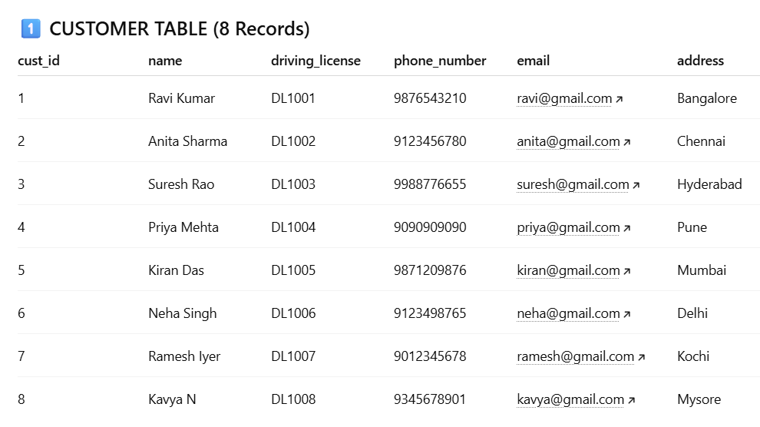

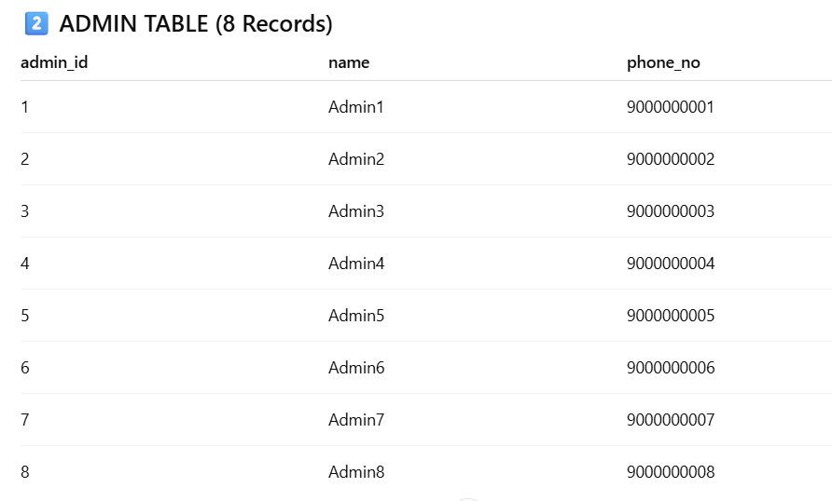

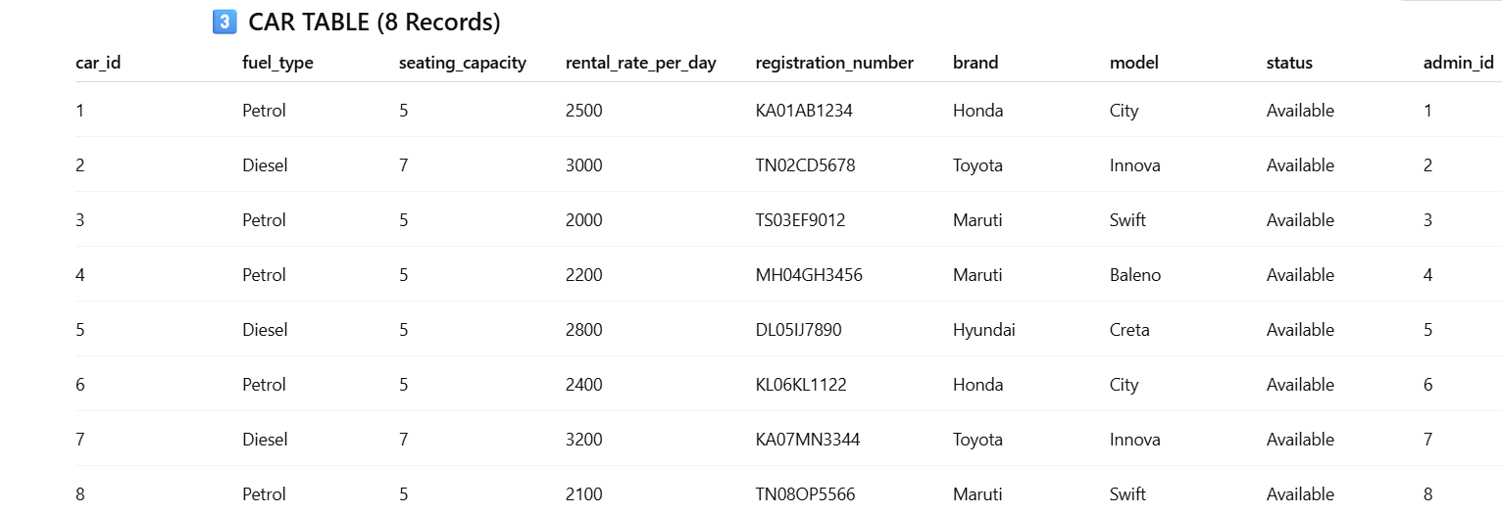

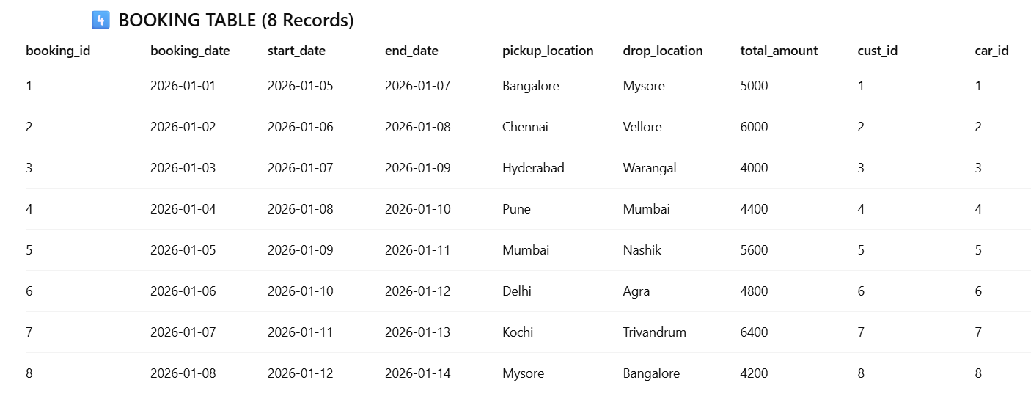

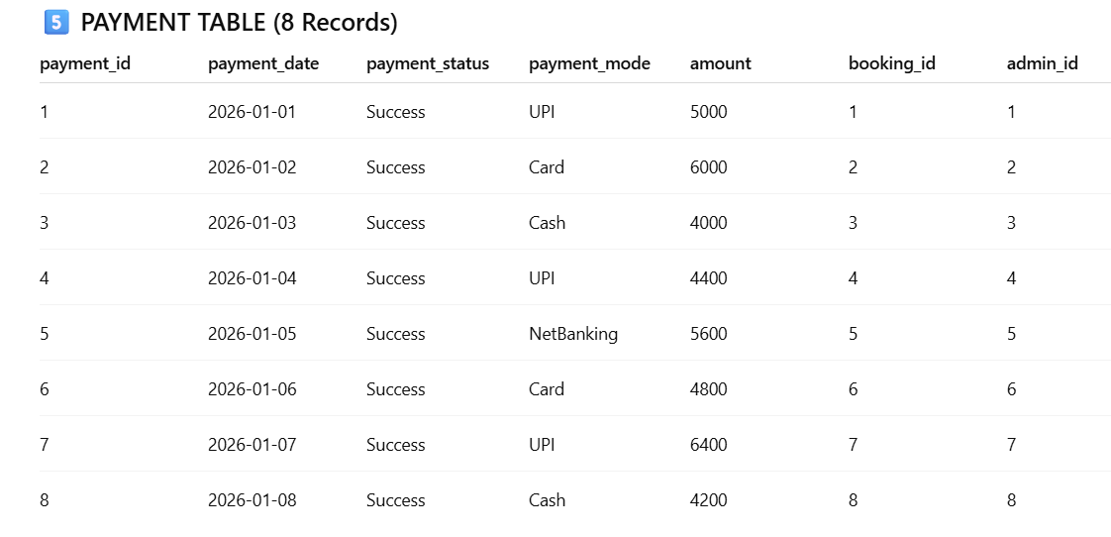

SQL QUERIES

- Aggregate Function – COUNT
Find total number of customers

SELECT COUNT(*) AS total_customers
FROM CUSTOMER;

2. Aggregate Function – SUM
Find total revenue generated from all payments

SELECT SUM(amount) AS total_revenue
FROM PAYMENT
WHERE payment_status = 'Success';

3.Aggregate Function – AVG

Find average rental rate per day of cars
SELECT AVG(rental_rate_per_day) AS avg_rent
FROM CAR;

4. Six-Clause Query
Find number of bookings per car with total amount > 5000
SELECT car_id, COUNT(*) AS total_bookings
FROM BOOKING
WHERE total_amount > 5000
GROUP BY car_id
HAVING COUNT(*) >= 1
ORDER BY car_id;

5. Simple Nested Query
Find customers who have made at least one booking
SELECT name
FROM CUSTOMER
WHERE cust_id IN (
SELECT cust_id
FROM BOOKING
);

6. Simple Nested Query
Find cars that have been booked
SELECT car_id, model
FROM CAR
WHERE car_id IN (
SELECT car_id
FROM BOOKING
);

7. Correlated Subquery
Find customers who made bookings with amount greater than average booking amount
SELECT name
FROM CUSTOMER c
WHERE EXISTS (
SELECT 1
FROM BOOKING b
WHERE b.cust_id = c.cust_id
AND b.total_amount > (
SELECT AVG(total_amount)
FROM BOOKING
)
);

8. Complex Query (JOIN + Aggregate)
Find total payment amount handled by each admin
SELECT a.admin_id, a.name, SUM(p.amount) AS total_handled
FROM ADMIN a
JOIN PAYMENT p ON a.admin_id = p.admin_id
GROUP BY a.admin_id, a.name;

9. Complex Query (Multiple JOINs)
Display customer name, car model, and booking amount
SELECT c.name AS customer_name,
ca.model AS car_model,
b.total_amount
FROM CUSTOMER c
JOIN BOOKING b ON c.cust_id = b.cust_id
JOIN CAR ca ON b.car_id = ca.car_id;

10. Correlated Query
Find cars whose rental rate is higher than the average rental rate
SELECT car_id, model, rental_rate_per_day
FROM CAR c
WHERE rental_rate_per_day > (
SELECT AVG(rental_rate_per_day)
FROM CAR
WHERE fuel_type = c.fuel_type
);
11.Write a PL/SQL program to check whether a car is available or not
DECLARE
car_status CAR.status%TYPE;
BEGIN
SELECT status
INTO car_status
FROM CAR
WHERE car_id = 201;
IF car_status = 'Available' THEN
DBMS_OUTPUT.PUT_LINE('Car is available for booking');
ELSE
DBMS_OUTPUT.PUT_LINE('Car is not available');
END IF;
END /
12.Write a PL/SQL program to update car status after successful payment
DECLARE
pay_status PAYMENT.payment_status%TYPE;
v_car_id BOOKING.car_id%TYPE;
BEGIN
SELECT p.payment_status, b.car_id
INTO pay_status, v_car_id
FROM PAYMENT p
JOIN BOOKING b ON p.booking_id = b.booking_id
WHERE p.payment_id = 301;

IF pay_status = 'Successful' THEN
UPDATE CAR
SET status = 'Not Available'
WHERE car_id = v_car_id;

DBMS_OUTPUT.PUT_LINE('Car status updated successfully');
ELSE
DBMS_OUTPUT.PUT_LINE('Payment not successful. Car status unchanged');
END IF;

COMMIT;
END;
/

